How to troubleshoot password policy requirements in MySQL
While attempting to create the WordPress user within MySQL, you encounter ERROR 1819, which states:

Scroll up to MySQL installation and confirm the password policy value is LOW.

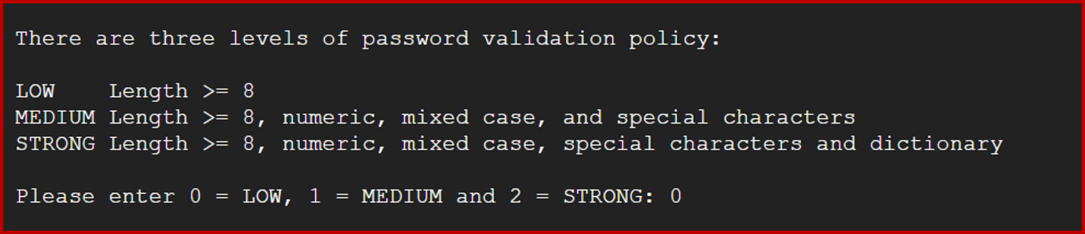

Once confirmed, command MySQL to:

SHOW VARIABLES LIKE ‘validate_password%’;

The table MySQL then generates will offer the requirements to validate the password. Locate validate_password.policy. Note that MySQL, by default, set the value as MEDIUM instead of LOW, which improved the password strength by increasing the password requirements.

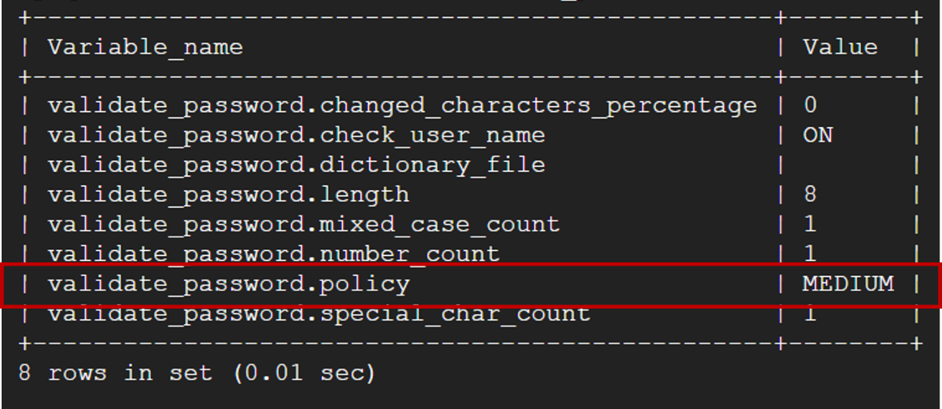

Now, you can follow along with one of the methods described below:

Method 1:
Create a WordPress user password that satisfies the new policy requirements through your CLI with alter or create:
alter user ‘wordpress’@localhost’ identified by ‘V@lidP4$$word’;
OR
create user ‘wordpress’@’localhost’ identified by ‘V@lidP4$$word’;

Method 2:
Type into your CLI (where LOW = 0):
SET GLOBAL validate_password.policy = 0;
Then, use the create dialog line from Method 1 with a modified password:
create user ‘wordpress’@’localhost’ identified by ‘NewValidPasswordForSuccess’;
Either method should yield the creation of your WordPress user as denoted by the Query, OK dialog line out within MySQL.

